PostMapping(“/authenticate”)

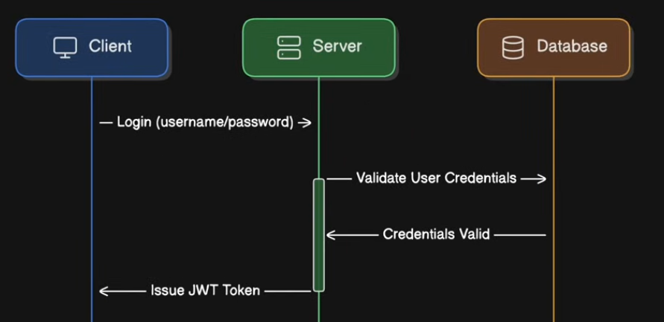

DeleteMapping(“/delete-product”)

